Making Government Easy

I want to remind the residents of Pound Ridge that our Community Outreach Mobile Office will be visiting Pound Ridge Town Park on Thursday, September 18, 2025 from 10:00a.m. - 1:00p.m.

Apply for a Passport.

Do not wait until the last minute: The US Department of State estimates 4 to 6 weeks to process passport applications and an up to 2 to 3 weeks processing time for applications that are expedited at an additional charge. If you need your passport in less time, you must make an appointment to take your paperwork directly to a Regional Passport Office. Please visit the U.S. Department of State website at www.travel.state.gov for details.

- Be sure to bring the proper documentation:
You will need proof that you are a US citizen such as an original or certified copy of your birth certificate, a consular report of birth abroad or a naturalization certificate. You will also need proof of your identity such as a current valid driver’s license or a government issued identification card. If your Adult passport is expired OVER 5 years, you must apply with us by bringing your old passport. If your passport expired UNDER 5 years, you must renew by mail with a DS-82 application. For minors under the age of 16, both parents should appear together and sign the application of the child. If only one parent appears and signs, that parent must submit the other parent's notarized Statement of Consent form (DS-3053) and a photocopy of his/her identification. The Statement of Consent form can be found at www.WestchesterClerk.com.

- Fees:
Adult passport fee is $130.00; Minor under the age of 16 fee is $100.00. Fees can be paid only by money order or check made out to the US Department of State. There is an additional $35.00 service fee that can be paid by credit card, money order or check payable to the Westchester County Clerk. You can get a 2x2 photo taken at the Mobile Office for $10 ($7 for seniors). If you have questions about whether you have what you need to apply, do not hesitate to call our office at 995-3082 weekdays between 8:30 a.m. and 4:00 p.m. or visit our website at www.WestchesterClerk.com.

Complete your Passport Renewal Application.

Due to the US Department of State requirements, our office can no longer accept renewal applications (DS-82 Renewal by Mail). The DS-82 must be mailed to the US Department of State by the applicant. Although you cannot leave your DS-82 with us to mail, our staff is available to assist in completing the form and you can get your photo taken.

Obtain Notary Services.

In-person notary services will be available free of charge. Bring photo ID.

Preserve Your Military Discharge Papers.
The County Clerk serves as a safe and local depository for your DD-214. Your DD-214 will be copied (you keep the original) and kept on file.
File Your Business Certificate.
If you are conducting any business in Westchester County under a name other than your own, and are not a corporation, limited partnership or limited liability company, you must file a Business Certificate in our office. Filing fee of $35 can be paid by credit card, money order or check payable to the Westchester County Clerk. Bring photo ID.
We look forward to the opportunity to help you when our staff visits.
Sincerely,
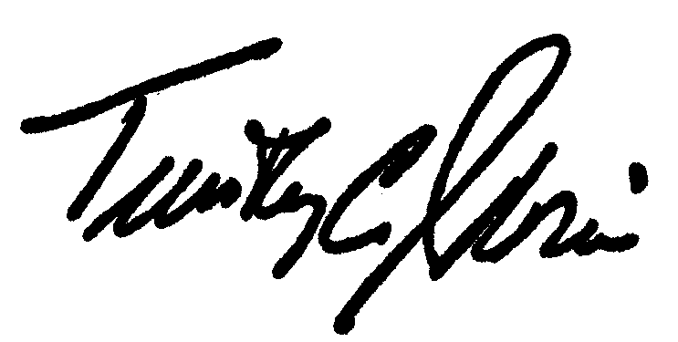
Timothy C. Idoni
Westchester County Clerk

